Hidrogenul II

Principala problema ridicata de sursele de energie reutilizabile, este stocarea. Energia electrica este de obicei utilizata ca atare, iar pentru stocarea ei exista deja solutii. In ce priveste energia solara si eoliana, insa, stocarea acestor forme de energie pentru ….
Hydrogenul poate stoca energie tot asa cum produsele petroliere stocheaza energie.
“Purtator de energie” Sursa primara de energie poate fi orice sursa reutilizabila, de exemplu a vantului, biomasei sau altele, dar avantajul utilizarii hydrogenului ca mediu de stocare este ca vom putea utiliza energia stocata de acesta pentru aplicatii mobile (auto, aviatie etc).
Proprietati
Hidrogenul este incolor indoor neotravitor
Greutatea specifica este de 0.09g/l, de 14.4 ori mai usor decat aerul.
Hidrogenul se condenseaza la -252.77°C iar greutatea specifica a hidrogenului lichefiat este de 71 g/L, ceea ce ii confera cea mai mare densitate de energie pe unitatea de masa intre toti combustibilii si purtatorii de energie: 1 kg de hidrogen contine la fel de multa energie ca si 2.1 kg de gaze naturale sau 2.8 kg petrol.
Densitatea de energie pe unitatea de volum a hidrogenului lichefiat este un sfert din cea a petrolului si o treime din cea a gazelor naturale.
Avantaje ecologice
Arderea hidrogenului in motoare cu combustie interna sau turbine de gaze produce emisii neglijabile de noxe.
Daca este folosit in baterii celulare de joasa temperatura ex PEMFC emisiile pot fi reduse la zero. In procesul de generare a energiei din hydrogen si aer sau oxygen singurul produs de reactie este apa distilata.
In baterii celulare de temperatura inalta, emisiile sunt de o suta de ori mai mici decat in termocentrale conventionale.

Obtinerea hidrogenului.
Hidrogenul nu poate fi gasit in natura in stare pura, adica in starea in care poate fi folosit ca purtator de energie), deci nu poate fi exploatat la fel ca petorolul sau carbunele. Deoarece trebuie extras din compusi chimici, oamenii de stiinta il denumesc “purtator de energie secundar”.
Cel mai cunoscut compus este apa, ce contine doi atomi de hydrogen si unul de oxygen, dar exista si alte substante ce contin hydrogen, de exemplu metanul, care contine un atom de carbon si 4 atomi de hydrogen. Biomasa este un alta exemplu de continut bogat in carbon si hydrogen.
Indiferent de sursa din care extragem hidrogenul, este nevoie de un process de obtinere si acesta presupune un consum de enrgie. Marele avantaj, insa este ca pentru generarea hidrgoenului nu este strict necesar sa utilizam energie provenita din combustibili fosili. Energie eoliana, solara sau a apelor….
Productia de hydrogen nu este ceva de data recenta. In fiecare an, cca 500 miliarde de metri cubi de hydrogen sunt produsi, stocati, transportati si utilizati, cu precadere in industria chimica si petrochimica. Cea mai mare parte insa este obtinuta ca un produs secundar din prelucrarea combustibililor fosili (petrol si gaze naturale)
Electroliza, adica obtinerea hidrogenuli din apa este in present, precum si in viitorul apropiat, singurul process cu aplicabilitate practica. Deocamdata, din punct de vedere economic, electroliza este o alternativa buna numai in acele tari in care exsita mari hidrocentreale, deoarece foloseste energie electirca, adica tot un purtator secundar de energie, care trebuie sa fie obtinuta ieftin.
Hidrogenul permite utilizarea energiei provenite din surse regenerabile, jucand rolul unui combustibil pentru autovehicule sau combustibil in care produc energie electrica sau termica. In viitor oricine va putea conduce sau gati folosind hydrogen generat din energie solara sau eoliana. In particular, hidrogenul este singurul purtator de energie (agent energetic) care face posibila propulsarea aeronavelor folosind energia solara.
In privinta mijloacelor de transport, hidrgoenul poate servi drept combustibil pentru aproape orice autovehicul. Exista doua moduri in care
Hidrogenul poate arde in motoarele conventionale in locul benzinei
Hidrogenul poate fi utilizat in baterii FC care genereaza energie electirca pentru masinile cu motor electric.
Avantaje majore al optinuii FC
Pe teava de esapament nu iese decat apa!
Nu exista zgomot si vibratii ca la motorul cu ardere interna
Motoarele electrice au randament mai bun, deci se reduce si consumul de energie.
O masina cu FC oprita la semafor nu produce zgomot, pur si simplu deoarece motorul ei nu functioneaza
Zgomotul este mult redus la demaraje, deci poluarea fonica a oraselor va fi mult redusa.
Marii producatori de automobile au pus deja la punct modele de masini care merg pe solutia FC, desi unii inca cerceteaza motoarele cu combustie. Probabil ca in 2005 vom vedea primele autoturisme de serie functionand cu FC, dar decizia nu este definitv luata, daca in FC va fi methanol sau hydrogen. Deocamdata nu exista o infrastructura a statiilor de alimentare cu FC.
Si pentru autobuze exuista cele doua concepte diferite, de motor cu combustie si FC. Ambele sunt mult mai putin poluante decat autobuzele diesel.
Microbuze si camioane
Nave
Since the beginning of the 90`s Daimler-Chrysler Aerospace and Tupolev co-operate in the field of cryogen aircraft technology. This co-operation is called Cryoplane Program. The aim is to switch the engines of a turboprop-aircraft (DO 328) over to hydrogen propulsion and to install a hydrogen supply system on board. The experience to be gained in this project can be transferred to big passenger aircrafts (Airbus) later
Hydrogen at home
The most important stationary application of fuel cells and hydrogen is the co-generation of electric power and heat in a fuel cell heating and power station. The advantage of making use of both products - electric power and heat - is the very high overall system efficiency thus making the best possible use of the primary energy sources

Such cogeneration fuel cell power stations can be realised even in very small construction sizes. Most common will be systems having the size of regular residential heating systems or of gas heating boilers. When these systems were produced in large numbers they would be only slightly more expensive than conventional heating boilers but in addition they are "incidentally" generating electric power!
One can imagine how our energy system would change if millions of such plants were installed directly in residential buildings. The generation of electric power would become decentralised and we would use the primary energy sources more efficiently

Hydrogen in your hands
A great variety of possible applications for fuel cells and hydrogen can be found in the energy supply of portable devices: mobile phones, laptops, walkmen, camcorders and many other things could be powered by hydrogen and by fuel cells in the size of batteries.
In this exposition you can have a look at a computer powered by a fuel cell. Its operation time far exceeds the operation time of computers powered by conventional accumulators. And when the hydrogen draws to an end one simply inserts a new cartridge. The empty cartridges can be refilled.
Fuel cells which are even smaller, so called micro fuel cells, could be integrated in mobile phones. Prototypes with an operation time of fifty hours have already been presente
Is hydrogen dangerous?
Hydrogen is highly inflammable, that means it easily reacts with oxygen and when it burns water is produced. Exactly this characteristic makes it suitable as a fuel.
Hydrogen has no greater danger potential than oil, natural gas or uranium. With regard to its physical and chemical specifications hydrogen is not particularly dangerous. Therefore, e.g. in Germany, the safety precautions and regulations for hydrogen do not differ from those for every other burnable gas.
In car accidents or air crashes liquid fuels often lead to fire slicks and in consequence frequently result in fatal injuries. In contrast to this hydrogen escapes upwards into the air very fast as proved by the accident of the airship "Hindenburg" in 1937. On the other hand one has to consider that there is an increased explosion hazard when hydrogen is set free in closed rooms, e.g. in garages or tunnels. In closed rooms good ventilation and perhaps additional safety precautions must be provided.
The chemical industry has been using hydrogen for hundred years. The experiences concerning safety are positive.
Hydrogen and fuel cells - a perfect combination
In this chapter we learn the basic facts of fuel cells. What for we need fuel cells, how they work and what is already reality.
Fuel cells gives us a very efficient way to produce electric power and heat. In the whole circle of renewable energies they are the final element. The sun provides energy, solar cells or wind power catch it for us, hydrogen is the storage and the medium to transport the energy and the fuel cells generate the energy whenever and whereever it is needed.
If we get into our car, if we need heat and electricity at home or if we just listen music on our walkmen. The energy could be provided by a fuel cell.
Basic construction
Fuel cells have a very simple structure. The cell itself consists of three layers, one above the other:
The first layer is the anode, the second an electrolyte and the third layer is the cathode.
Anode and cathode serve as catalyst. The layer in the middle consists of a carrier structure which absorbs the electrolyte. In different types of fuel cells different substances are used as electrolyte. Some electrolytes are liquid and some are solid with a membrane structure.
Because one cell generates only low voltage several cells get stacked according to the requested voltage. This arrangement is called "stack".
What exactly does a fuel cell?
The fuel cell reverses the process of electrolysis which is known from school. In the process of electrolysis by applying electric power water is decomposed into the gaseous components oxygen and hydrogen.
The fuel cell takes exactly these two substances and converts them to water again. In theory the same amount of energy which has been used for the electrolysis is set free by this conversion. In practice insignificant losses are caused by different physical-chemical processes.
So to say electric power is stored in hydrogen. Therefore we have a gas at our disposal in which electric power can be stored and this gas is hydrogen. In fuel cells we get back the electric power stored in the hydrogen. Most fuel cells are operating with air, so there is no need to store oxygen.

HyNet Hydrogen Information Site  Welcome to HyNet's hydrogen, energy and fuel cell information site!  In three short chapters we will introduce you to some basic facts in the fields "Energy", "Hydrogen" and "Fuel Cells".  After reading all three chapters you will be able to understand what hydrogen is, what for we need hydrogen, and what a fuel cell is.  Further you can find out how an hydrogen economy works and why it is a perfect solution for the energy of today and for the future! | 

Energy the Driver
We need energy for a lot of purposes in our every day life. Whether we use the refrigerator, TV, computer whether we drive by car or by subway or whether we only enjoy light and heat, the driving force is always energy.
But energy is finite! We generate more than 90% of our energy from fossil sources like oil, gas or coal. During the next fifty years we will deplete almost all the remaining oil and gas on the world.

Mankind is growing  Never before have lived as many people on our planet as today. There are more then six billion people now, and their number will increase further.  On which scale it will increase, no one can say with certainty. If you take a look at the UN scenario of the least growth, you will see that there will be up to 9 billion people in 2050. This scenario would demand very drastic measures and therefore the actual population will be supposedly higher in reality.  Extrapolating this trend there will be 13 billion people in one hundred years. All those people have a right to meet their basic needs for food, housing, heating, education. |  | Therefore we need huge amounts of energy! Now more than 2 billion people have no access to electric power. Therefore they do not participate in energy consumption yet.  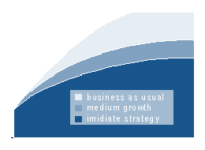  United Nations growth scenarios
Can the way of living in the industrialized countries serve as a model for the world?  Considering who is using the energy today one finds a striking imbalance. Only 17% of mankind live in industrial nations but nevertheless they have a share of more than 60% on the total energy consumption!  How are our energy requirements met today?  More then 90% of today's energy supply consists of coal, petroleum and gas. So we meet 90% of our energy requirement by burning fossil fuels.  At today's consumption rate petroleum, our most important fuel, lasts for another 40 to 50 years. One can easily work out what would happen if the other 83% of mankind consumed as much energy as we do: In less than 10 years the world's remaining petroleum would be used up!  Therefore resolving the world energy problem has to start with us. We have to reduce our energy consumption and we have to introduce modern technologies. In actual fact the developing countries do not yet participate in global energy consumption!
  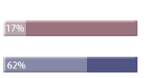
  17 % of the world's population needs 62 %
  of the world's energy. That means that 83 %
  of mankind shares the remaining 38 %
  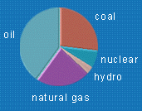
  today more then 90 % of the world's energy supply
  is meet by fossile resources

Today's energy is fossil  Fossil fuels are coal, petroleum and natural gas. They are not renewable, once burnt they are gone forever.  These sources supply more then 90% of our energy requirement.  In this context two problems are paramount. One problem is the question for how many years these fuels will be available. The other problem is the pollution caused by burning fossil fuels.  That's why we subdiveded the fossil chapter into two subchapters: Climate and Resources | 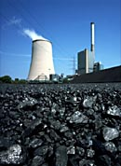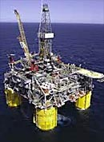

Energy Conservation is a Means of Climate Protection  The graph on the right shows the development of the average temperatures in the last 140 years. The trend shows a clear increase of temperatures. The graph also shows the increasing concentration of carbon dioxide in the atmosphere. This is mainly due to the burning of the fossil fuels coal, oil and gas.  During the last 50 years the mean temperature on earth increased by about 1degree. At first this does not sound too dramatic. But this increase has caused a dramatic reduction of the size of alpine glaciers and the beginning melting of huge areas of ice in the polar region.  Most important an increase of the average temperature by 1degree leads to an increase in the occurrence of weather extremes like periods of draught, storms, floods etc. Biological adaptation processes can not happen at that fast rate of change, the variety of species begins to decrease. Particularly within insurance companies there is a growing awareness that natural disasters are a consequence of climate change.  The causal correlation between climate change and the emission of carbon dioxide can at the moment not be proven with final certainty-but also the proof of the contrary is not possible. Yet all measurements confirm this theory. Our grandchildren and great-grandchildren will have to take the consequences of our experiments with atmosphere - this should be reason enough for us to act.  If the prognosticated increase in energy demand is to be met by fossil fuels then the world-wide emissions of greenhouse gases will have doubled by 2030!
  
  The grafic shows the temperature divergences from the mean value. Warmer years are green, colder years are blue. The last decade had been the warmest in the last century. The orange line represents the increasing carbon dioxide concentration in the atmosphere.
  
  Satelites view of a hurricane
  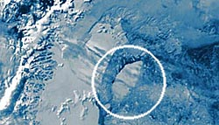
  A 2000 square kilometers iceberg breaks off the "Larsen Shelf ice" near the south pole.

World Energy Resources  The graph on the right shows the reserve-to-production ratios for those fuels which meet almost 100% of today's requirements (i.e. the remaining number of years these fuels would last at our present level of consumption.)  It is not realistic to assume that there will be no increase in consumption. Therefore the graph below shows the reserve-to-production ratios assuming a 1% yearly increase in the consumption of crude oil and a 1.5% increase per year in the consumption of natural gas and coal. One can see clearly how the reserve-to-production ratios are decreasing. This representation is called the dynamic reserve-to-production ratio. It should be noted that the assumed rate of increase in consumption is rather moderate.  Oil and Gas  Those two fuels together meet more then 60% of the world's energy demand. Both fuels will be depleted in a few decades.  The IEA (International Energy Agency) -an institution of the United Nations- predicts an increasing gap between supply and demand starting in 2010. At first this gap will not be dramatic but no one can say for sure how the energy prices will develop in future. In any case demand will exceed supply.  A large part of the fossil resources -about half- has been used up in the last 100 years. Even in relation to the age of mankind this is a very short period of time.  Therefore it is less important whether fossil fuels will be depleted in 50 or rather in 70 years but the real issue is whether mankind should use them to the very end at all. The use of fossil fuels poses - apart from the problem of greenhouse gases- the question of a just distribution of resources. The generations to come will lack these resources we are using at such a great extent. We live at the expense of future generations.  We have the responsibility to develop and to apply alternative technologies, in order that coming generations can be sure to meet their energy requirement!
  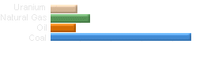
  Static range of fossil energy carriers (years)
  
  Dynamic range of fossil energy carriers (years)
  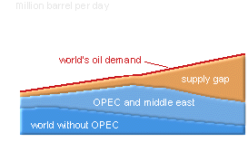
  The development of oil demand seen with the eyes of IEA 1999.
  In the year 2024 the gap between demand and production corresponds to the worlds production amount of 1997. The blue areas show the decrease of production.

A sustainable solution  The sun could be the solution to all energy supply problems - already now and in future!  The sun radiates many times more energy down to earth than we require: Every day, without emissions and completely free. We just have to find ways of using this energy.  In principle all renewable energy sources originate from the sun. The sun makes the wind blow, causes rain to fall and heats our planet.  The term "renewable" energy means that this energy is not taken from a finite stock but is generated in a cyclical process. Scientists talk of "sustainability" in this context.  This can be explained very graphic taking wood (one type of biomass) as an example: The sun causes a tree to grow and this tree produces oxygen and binds carbon dioxide. To burn the wood we need oxygen and we get carbon dioxide as a result. Over all these processes are balanced but we gained thermal energy. Virtually the tree has stored solar energy for us.  For every renewable energy source there is such a balanced cyclical process. This is the decisive benefit of renewable energy sources!  On the following pages we want to present you some of the most important technologies for renewable energy sources. They do not compete but supplement each other. Also today electric power is generated partly from coal, petroleum, natural gas or uranium.  An even greater number of options is characteristic for the renewable energy sources. Hydrogen is the perfect connection between these options! | 

Solar energy  Direct use of solar energy means that electricity or heat is generated directly from the sun. An indirect use of solar energy is e.g. windpower.  To generate energy directly from the sun, there are different possibilities. Photovoltaics converts solar energy directly into electric power. Solar thermal installations use the sun to produce heat which is either used directly as heat or in solar thermal power stations steam is generated to produce electric power.  The passive use of solar energy is another solar technology. Whenever a building or the facade of a building is constructed in such a way that it collects energy then this is called solar architecture. In principle it is possible to supply a house with energy entirely by the sun, even in our climes. Additional energy from fossil fuels is unnecessary. Such "zero-energy-houses" are state of the art technology today and even construction costs are only slightly higher than those of conventional houses.  Where as right now 1 kilowatt hour of electric power from photovoltaics costs well over 50 Cent solar thermal hot-water systems are already competitive.  Photovoltaics has the potential to become much cheaper as well. In principle the technology is simple and silicium (for the production of wafers) is one of the most frequent elements in the world. Only the necessary mass production is missing! |   solar cell  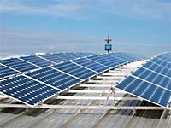  1 MW photovotaic system on the roof of the munich fair  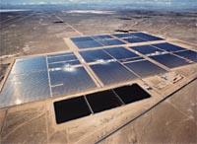  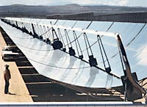  150 MW solar thermal power plant (USA)

Power from wind and water  Man has used these two renewable energy sources for a very long time. In the past windpower has been used to sail around the world and with the aid of waterpower grain has been ground in the Middle Ages. Windmills have existed for many hundred years!  Modern power generating installations are using both energy sources. There are many hydroelectric power stations which have been producing energy for many decades.  Hydroelectric power stations are good base load power stations because one can reliably predict their output. But the potential of waterpower is restricted and not all countries have enough water at their disposal. Waterpower will also in future have a stable share in renewable energy sources.  The global potential of windpower is immense. Wind farms can be built onshore as well as offshore. So called offshore-wind farms work on perfect wind conditions and they do not disturb anyone out there.  Europe is the world champion in using windpower. Installed power has already reached 25,000 megawatt (33,000 MW worldwide). This is sufficient to meet 1.6% of electricity production in Europe. Unfortunately the wind does not blow all the time and we therefore have to keep power plants in stand-by. Hydrogen can be useful to store wind power in future.  Wind power is a good example to demonstrate how dynamic the development of technologies for renewable energy sources can become once they reach profitability. In 1993 only under 200 megawatt had been installed and the prognosticated yearly growth was less than 100 megawatt up to 2015. The actual growth turned out to be 6000 megawatt per year! | 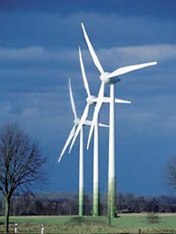  wind farm  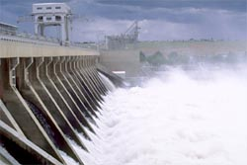  hydro power  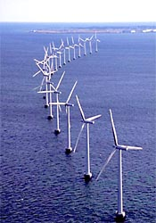  offshore wind farm

Energy from farming  The energetic use of biomass has much potential world-wide and can get an important share in European energy supply as well.  There are different types of biomass. One is "bio-garbage" coming from our households. It is especially suited for gasification: In an accelerated process of putrefaction methane is produced, which can be used directly to generate electric power. When required also hydrogen can be produced from methane.  All sorts of organic waste from agriculture and forestry are also forms of biomass and there are different technologies and methods to utilise them. As pellets it can be used in modern biomass-ovens to generate heat but of course also cogeneration is possible.  This type of biomass together with plants especially cultivated for this purpose can be converted to hydrogen in a biomass-reformer. In this process a lot of carbon dioxide is produced but only as much as has been absorbed from air by the plants before.  Part of the hydrogen which is needed for fuel cell cars and residential fuel cell systems could in future be produced by agriculture. |     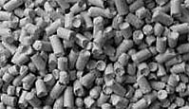  bio mass pellets for burning in combined  heat power stations  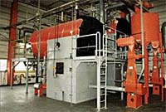  power station for pellets

Further renewable options  Apart from the already demonstrated types of renewable electric power production there are some technologies which are not so well known or not so well developed. Some of them we want to present:  Geothermics  In many regions of the world there are subterranean sources of heat. Sometimes they are so hot that one can use their energy. Nearly hundred percent of the energy supply of Iceland are based on this energy. Only the fuels for cars and ships are derived from crude oil. Iceland wants to become independent of these oil imports as well and has decided to switch the whole energy economy over to hydrogen. They want to generate hydrogen by geothermal energy in future. Many European partners are supporting this project.  In Europe there is an unused potential of geothermics as well. It is imaginable that it will supplement our supply of energy in future.  Energy from The Sea  Ebb and flow are moving immense masses of water every day. Enormous amounts of energy are necessary to bring this about. Tidal power stations are able to use this energy. Such a tidal power station has existed in St. Malo at the French Atlantic coast for many years.  The power of the waves can be used as well. Mostly in Britain there are prototypes of such wave power stations. They are built on the seabed and use the sea's up and down movement. The energy contained in waves several metres high is considerable in any case. But the question remains whether we succeed in using them.  Certain sorts of algae are a perfect source for biomass. With algae farms the immense area of the sea could be used in a natural way!  Other Solar Power Stations  Apart from the thermo solar and photovoltaic power stations there are various other types. There one should mention up current thermal power stations and tower power stations. Both technologies have already been tested successfully.  Up current thermal power stations use the fact that hot air is lighter than cold air. On the ground of the tower air gets heated by the sun. The air then rises in the tower and drives a turbine.  In tower power stations hundreds of mirrors focus the sunlight on top of a tower where water vaporises. The steam then drives a turbine. | 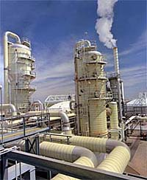  geothermal california    St. Malo in France (240 MW)

Nuclear Power  Nuclear power is undoubted the most controverse way of producing energy throughout Europe.  Several European countries already decided to quit the use of nuclear energy due to the risks and to the unsolved problem of nuclear waste, others will rely on nuclear power even in the future.  Today there are about 400 nuclear power plants world-wide. Their energy meets just under 7% of the global energy demand. If nuclear energy is to make a relevant contribution to the future supply of energy we would need several thousand new power plants. During the next 40 years we would have to take a new reactor into operation about every second day if this power source should be available when all sources of fossil energies are used up.  At the present consumption rate natural uranium will last for just under 100 years. If power stations with today's technology were built then the uranium stocks would be used up in a very short period of time.  The only way out would be the nuclear breeder technology, its fuels are reprocessable to nearly hundred percent. World-wide the breeder technology is not pursued any more. Nuclear breeders have the disadvantage of needing highly toxic plutonium and producing radioactive waste with long half-life which we have to keep safe for thousends of years.  Society will have to decide whether it wants to introduce in a large scale a technology which holds a certain danger potential and which confronts many future generations with the problem of the disposal of nuclear materials.  This is especially relevant if you take into consideration that renewable energy sources give us the possibility to generate energy in a sustainable and safe way and that there we have technologies which are much easier to handle for all the people in the world.  There remains the problem of profitability. The price of energy generated from renewable energy sources will decrease when the use increases. Nevertheless it will never arrive at the price we pay for our energy today. Therefore it is society's responsibility to start appreciating the value of renewable energy sources and to perceive their use as a way towards a better quality of life.  Thermo Nuclear Fusion  No one can say for sure whether nuclear fusion reactors are ever going to work. Even the scientists who are working on fusion research talk about reactors fit for operation only in 50 years. But for several reasons it is important that at that time we already have at our disposal a working and clean supply of energy. |  | 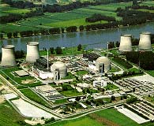  nuclear power station
What for we need hydrogen?
As a result of the "Energy" chapter we can see that a world energy supply only based on renewable sources is possible. We have the potential and we have the technologies.
One problem that accompanies all renewable energies is the storage. If we use electrical energy it is always most efficient to use it directly. The electrical grid is a kind of storage for that. But if the amount for instance of solar and wind power grows there will be a need to store the energy for example if it needs to be used at nighttime.
Even for mobile and portable applications we need an "Energy Carrier" to use the solar energy as a fuel for cars or in an aircraft.
Therefore we need hydrogen. Hydrogen can store energy like it is stored today by oil or by natural gas. That's why hydrogen is called a secondary energy carrier. You need a primary energy to produce. But at the same time it is a big advantage because for production various sources can be used.
So you can fly or drive by wind power, by biomass or by many other renewable sources.
This chapter will explain all about the production, the storage and the use of hydrogen.

Physical Specification  Hydrogen is a colourless, odourless and completely non-poisonous gas. It has a specific gravity of 0.0899g/l (Air is 14.4 times as heavy)  Hydrogen condenses at -252.77°C. Liquid-hydrogen has a specific gravity of 70.99 g/l. Because of that hydrogen has the highest energy density in relation to mass of all fuels and energy carriers: 1 kg hydrogen contains as much energy as 2.1 kg natural gas or 2.8 kg petrol.  The energy density referring to volume of liquid hydrogen is a quarter of petrol's and a third of natural gas's. The share of hydrogen of the weight of water is 11.2%.  Ecological Advantages of Hydrogen  When burning hydrogen with air in internal combustion engines and gas turbines (when a suitable procedure is applied) only very few or negligible emissions are resulting.  Nitrogen monoxide emissions increase exponentially with calorific intensity. Therefore these emissions can be influenced by choosing a suitable process. Because hydrogen, in contrast to other fuels, leaves us more freedom to influence the burning process it is possible to decrease the Nox-emissions compared with natural gas or petroleum. To achieve this one can attain low calorific intensity e.g. by using a high air surplus.  By using hydrogen in low-temperature fuel-cells ( e.g. membrane fuel cells: PEMFC) emissions can be avoided completely. In the process of generating energy from hydrogen and air-oxygen there is only water as a reaction product (i.e. water without any minerals, like distilled water).  The use of hydrogen in fuel-cells operating at a higher temperature-level causes emissions a hundred times lower than in conventional power stations. | 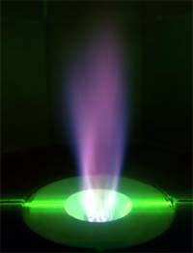  

How to get hydrogen?  Hydrogen in a pure form (and only as such an energy carrier) does not occur in nature but exists only in bond structures.  It therefore can not be exploited like crude oil or coal: it has to be generated from other chemical compounds. This is why scientists call it a secondary energy carrier.  Of course the best example for a hydrogen-compound is water. Two hydrogen-atoms and one oxygen-atom form water. But there are many other substances which contain hydrogen.  Most organic compounds are a combination of carbon and hydrogen. An example for this is natural gas (methane) which consists of one carbon-atom and four hydrogen-atoms.  Plants consist of organic compounds which consist of carbon and hydrogen. Biomass in general, consists on the biggest part of carbon and hydrogen: e.g. refuse containing biomass, refuse from plants, refuse wood from forests or especially cultivated energy plants like rape or particular grasses.  Independent from the base material hydrogen is always generated by a process. For this energy is needed.  It is an advantage of the use of hydrogen that the energy for its generation has not necessarily to be taken from fossil sources. Windpower, solar energy and waterpower are primary energy sources as well!  The production of hydrogen is not really new. At the moment world-wide every year 500 billion cubic metres of hydrogen are produced, stored, transported and used. This is happening mostly in the chemical (and petrochemical) industry.  Click left to see various ways of industrial hydrogen production... | 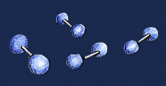  gaseous hydrogen molecules H2    water: two H , one O (H2O)  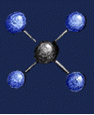  natural gas: one C, four H (CH4 - Methane)  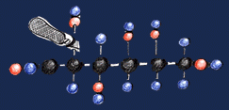  A typical organic combination.  Biomass consists dominantly of variations of this  organic chains. (here: glucose)

Hydrogen from fossil sources  Von The biggest part of todays 500 billion cubic metres world-wide is generated from fossil sources (natural gas, oil) or is obtained as by-product-hydrogen in chemical processes. A lot of hydrogen is obtained by chlor-alkali electrolysis and crude-oil-refinery-processes.  Altogether the hydrogen generation as by-product amounts to around 190 billion cubic metres world-wide.  There are the following processes to generate hydrogen from fossil fuels:  Small Reformer  To be able to use hydrogen in fuel cell applications in the near future small reformers (steam reforming, partial oxidation) are being developed. These systems are intended particularly for mobile use in vehicles and in small stationary applications.  For mobile applications one is hoping that the higher energy density and the easier handling of a conventional liquid fuel could be used to supply fuel cells. For this purpose the partial oxidation or reforming of methanol or gasoline is particularly important.  Steam Reforming  Steam reforming is the endothermic catalytic conversion of light hydrocarbons (methane,..., gasoline) in the presence of steam. This large-scale process normally takes place at a temperature of 850°C and a pressure of 2.5 bar. Hydrogen and carbon dioxide as well as methane and carbon monoxide are produced in the conversion process. In the so called "shift reaction" carbon monoxide reacts with steam to generate carbon dioxide and hydrogen. The carbon dioxide and other unwelcome constituents are removed from the gas mixture by adsorption or membrane-separation later on.  The separated residual gas which contains about 60% of combustible components (H2, CH4, CO) is used as a fuel in the reformer, together with a part of the input gas.  The large-scale generation of hydrogen is done in steam reformers with production capacities of usually 100.000 cubic metres of hydrogen per hour. These plants are built by companies like Linde, KTI or Uhde .  Partial Oxidation  Partial oxidation is the thermal conversion of heavy hydrocarbons (e.g. residues from oil refining or diesel oil) with oxygen and sometimes with additional water vapour. The amounts of oxygen and hydrogen are allocated in such a way that gasification without external energy supply is possible.  This hydrogen generation process works with coal as well. The coal is ground very fine and mixed with water into a pumpable suspension with 50-70% of solid matters. This process is profitable only in typical coal mining countries like China or South Africa. In Germany there are only pilot plants.  In case hydrogen is to play an important role in the energy economy in the medium or long-term it is not recommendable to base its generation on conventional steam reforming or partial oxidation from natural gas, oil or coal in view of the environmental requirements (CO2-reduction).  Modern Processes  Modern processes make it possible to generate hydrogen potentially without CO2 from natural gas and using electric power:  Since the beginning of the 80´s KVAERNER ENGINEERING S.A. from Norway is developing the plasma-arc-process which at 1600°C splits hydrocarbons into hydrogen and clean coal. For this process which causes no considerable emissions electric power and cooling water are needed in addition to the primary energy sources (petroleum, natural gas).  A pilot plant in operation since April 1992 generates 500kg/h clean-coal (activated carbon) and 2000 Nm3/h hydrogen from 1000 Nm3/h natural gas and 2100 kWe. As an additional by-product superheated steam with a power of 1000 kW is generated. Considering all potentially usable products the plant works with an efficiency of almost 100%. Of this output about 48% are contained in hydrogen, 10% in super heated steam and the remaining 40% in activated carbon.  The process is in the pilot phase. As a next step there are plans to build a plant with a capacity of 100.00 Nm3/h hydrogen under industrial conditions. | 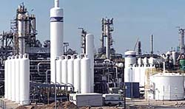  hydrogen production plant in Leuna, by Linde  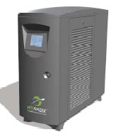  residential natural gas reformer by Hyradix  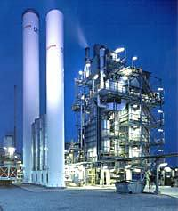  natural gas steam reformer by Air Liquide

Electrolysis  For the generation of hydrogen from water now and in the foreseeable future electrolysis is the only process of practical significance among the possible alternatives. The conventional process is the alkaline electrolysis which has been in commercial use for more then 80 years. Because hydrogen generated by electrolysis uses electric power (also a secondary energy carrier) this is economic only in those regions of the world where electric power can be generated very cheaply. This is the case almost exclusively in big hydroelectric plants (e.g. in Egypt, Iceland, Norway..)  General Description  The water decomposition via electrolysis takes place in two partial reactions at both electrodes, which are separated by an ion conducting electrolyte. At the negative electrode (cathode) hydrogen is produced and on the positive electrode (anode) oxygen is produced. The necessary charge exchange works via ion conduction. To keep the product gases separated the two reaction compartments are separated by an ion separator (diaphragm). The energy for the splitting of the water is provided by electric power. The following types of electrolysis exist:  Conventional Water Electrolysis  This process works with alkaline, aqueous electrolytes. Anode compartment and cathode compartment are separated by a microporous diaphragm to avoid the blending of the product gases. Good dynamic performance is a feature of the latest developments which allows for fluctuating operation. Therefore they are perfectly suited for applications with renewable energy generating plants.  High-Pressure Water Electrolysis  With high-pressure electrolyzers hydrogen pressures up to and even over 50 bar are possible. This is feasible because of a specific choice and optimisation of materials. Some technologies which are in the development stage at the moment shall make feasible an unproblematic operation of an electrolyzer powered by a fluctuating electric power unit (e.g. wind- or PV-power) thus enabling the building of stand-alone plants.  High-Temperature Electrolysis  High-temperature electrolysis has been discussed as an interesting alternative some years ago. It would be an advantage to put part of the energy needed for dissociation as high-temperature heat at around 800-1000°C into the process and then to be able to run the electrolysis with reduced electric power. These considerations were directed at using in this way the heat set free in a solar-concentrator or waste heat from power plants. But in the last years the interest in this type of electrolysis decreased and therefore we will not go into more detail. | 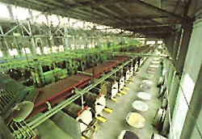  large scale electrolysis by norsk hydro  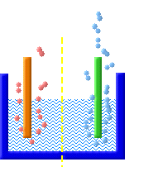  electrolysis from water    home electrolyser to refuel a car at home (stuart)  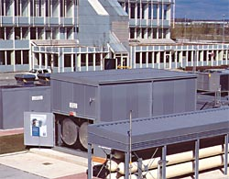  high pressure electrolyser by GHW  (at munich filling station)

Hydrogen from Biomass  Technologies for the generation of hydrogen from biomass are not commercially available so far. Dependent on the process they are at different stages of research and development.  Experts differentiate between the following methods for the generation of hydrogen: conversion of firm biomass (e.g. pellets from cultivation, residues consisting of biomass), fermentation of biomass like liquid-manure and biological generation of hydrogen.  The charming thing about generating H2 directly from biomass is that the generation of hydrogen is effected directly from the renewable energy source without taking the detour of converting the energy contained in the biomass to electric power (needed for electrolysis). By doing this a high system efficiency with a positive general balance is made possible.  The process of water vapour gasification of biomass generates a gas mixture which consists of  - 0% hydrogen  - 20% carbon monoxide  - 10% carbon dioxide  - just under 5% methane  - 45% nitrogen  When using pure oxygen or only water vapour the product gas contains no nitrogen.  In this process due to the heat the organic substances decompose into coke, condensate and gases before the gasification itself takes place. This process is called thermal decomposition or pyrolysis. Because of the oxygen present in the reactor the intermediate products are not reformed but there is a partial oxidation instead.  In a second phase of the shift-reaction the carbon monoxide together with water vapour is converted into hydrogen and carbon dioxide. After that the gas mixture is dissociated in a pressure-swing-absorption process into pure hydrogen and residual gas.  Fermentation of Biomass  Biogas can be generated by anaerobe methane fermentation when biomass or liquid manure contains a high percentage of moisture. Biogas contains a high percentage of carbon monoxide and methane. Even though this gas mixture contains very little hydrogen it can be used as fuel in advanced high-temperature fuel cells (MCFC). Because of the high process temperatures (~ 650°C) the reforming of the methane takes place directly at the electrode. Before it can be used in membrane fuel cells (PEM) the gas has to be converted into hydrogen in a reformer.  Biological Hydrogen Production  There are different biological processes in which hydrogen is set free or is produced as an intermediate product. In principle two different types of processes can be distinguished: The photosynthesis which requires light and the fermentation which takes place in darkness. Hydrogen is produced by algae in the first case and by micro-organisms in the latter case.  These methods of generating hydrogen are still in the development stage but they are a complementing option for a future hydrogen economy. |     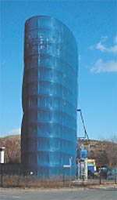  biomass gasification plant (Herten, Germany)

How to store hydrogen  Hydrogen serves as a storage and transportation medium for energy.  In general there are three different ways of storing hydrogen:  - storage in pressure tanks  - storage of liquid hydrogen  - storage via absorption  All of them have pros and cons which qualify them for different applications: | 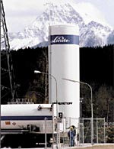

Storage of Pressurised Gas  We talk of the storage of pressurised gas whenever a gas is stored under higher than normal pressure. Tanks for the storage of pressurized gas differ by their construction according to the type of application which determine the required pressure levels. For the most part stationary tanks have a lower pressure level because this type of storage is cheaper. The requirements for mobile applications, for example in a motor vehicle, are quite different because there is not much room for tanks. For such applications tank pressure is increased up to 700 bar in order to store as much hydrogen as possible in a very confined space.  Pressure tanks used to be made from steel and therefore were very heavy. Modern pressure tanks are made from composite materials (coal-fibre composite materials with a thin internal aluminium liner) and they are much lighter.  When it is necessary to store large amounts of hydrogen in a future energy economy then hydrogen can be pressed into subterranean cavern storages. There it can be stored under a pressure of up to 50 bar. In France and in the USA this method is already in use. In Germany natural gas is stored in such caverns. They could be used for the storage of hydrogen in future. | 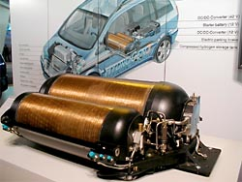  vehicle storage system (GM)  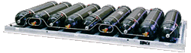  storage system for buses (roof system by MAN)  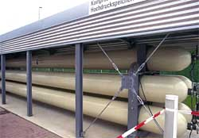  Stationary storage system at a filling station

Liquid storages for hydrogen  Hydrogen has the highest energy storage density referring to volume when it is liquefied before storing. Hydrogen is liquefied at -235°C.  Cryo-tanks - tanks for liquid gases at very low temperatures are called this - can be produced with very high quality today. The losses resulting from the gradual heating up of the liquid hydrogen in the tank (waste steam losses) can be kept very low. The storage of liquid hydrogen is especially suited for the use in vehicles because the space requirement of liquid hydrogen tanks is lowest.  For the re-fuelling of these vehicles automatic robots exist already.  Stationary liquid-storage will only be used when hydrogen is really requested in liquid form, e.g. in fuel stations. For all other applications the high amount of energy requested for the liquefaction should be avoided wherever possible. | 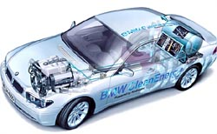  BMW with liquid hydrogen storage in the back    robot fueling station at munich airport

Adsorption Storage  Beside pressure gas and liquid gas storage there are other methods for the storage of hydrogen as well.  Metal hydride storage  This storage technology uses certain metal alloys which are storing hydrogen like a sponge becoming saturated with water. The hydrogen is adsorbed by the metal thus building metal hydrides.  If a metal hydride is "filled" with hydrogen it emits heat. To regain the hydrogen heat must be supplied.  Referring to the volume metal hydride storage has a very high storage capacity. Unfortunately those storages are quite heavy and therefore they can not be used in mobile applications. In addition they are very expensive because of the high costs of materials.  With regard to handling and safety there are advantages in the use of metal hydride tanks. Almost all of them operate at normal pressures, there are no losses and they effect a cleaning of the hydrogen. Hydrogen is released by the supply of heat and therefore the hydrogen remains bonded in case the tank is damaged.  In submarines this type of storage is in commercial use today.  Carbon Nanotubes  This material on carbon base may revolutionise the technology of storage for hydrogen one day. Some years ago it has been discovered that large amounts of hydrogen can be stored in tube-shaped microscopically small graphite-structures.  Meanwhile many groups are doing research on the storage technology world-wide. But up to now the reports on the storage capacity are differing very much.  Independent from each other several groups proved that this method of storage is working in principle and that it has a high potential. We can really look forward to the scientific and technical advances. | 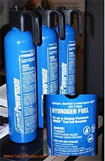  portable metal hydride storage  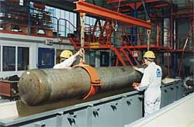  large scale metal hydride storage  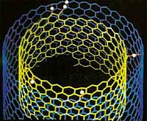  tubular graphite structures

Hydrogen supply  In principle hydrogen can be transported by using all the discussed storage technologies. Tank sizes will be rather big corresponding to the technologies.  Liquid hydrogen can be transported with trucks either in special trailers or in containers. In the USA there even exists a 40 km pipeline for liquid hydrogen.  Pressurized hydrogen today is delivered in mobile pressure tanks by truck or train from producer to consumer. In addition there is the option to build a pipeline system for the delivery of hydrogen which would principally correspond to our present natural gas mains. One day every household could be supplied with hydrogen instead of natural gas.  In the Ruhr Basin and in Leuna there has been a pipeline grid for hydrogen with a length well over 100 km for several decades. It is working without any problems. World-wide there are about 1000 km of hydrogen pipelines in operation.  Ships for the transport of liquid hydrogen could be very similar to the tankers for liquid natural gas which are used today. But new concepts for ships specially for the transport of liquid hydrogen have been designed in detail as well.  As long as there are only small amounts of hydrogen to be transported intercontinentally the transport in containers makes sense. These containers for liquid hydrogen are standardised and they can be transported world-wide with ships, trains and trucks. And they can be transferred in every container-terminal. | 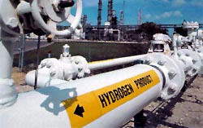  hydrogen pipeline  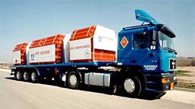  trailer for pressurized hydrogen  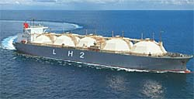  liquid gas vessel  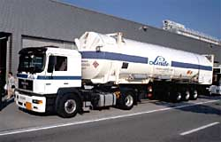  liquid hydrogen delivery trailer

Mobile or stationary  The use of hydrogen as an energy carrier will change many facets of our life in future. Together with the fuel cell it has the potential to revolutionise the whole energy economy.  Hydrogen enables the use of renewable energy sources: as a fuel in traffic or as a fuel for the co-generation of electric power and heat in stationary applications. Whoever wants to cook or to drive with hydrogen generated from solar energy or from windpower will be able to do so.  By the way, hydrogen is the only energy carrier which makes it possible to power an aircraft using solar energy!  Generally one can differentiate between three main areas for the use of hydrogen: Stationary, mobile and portable applications. Chose a category on the left and take a look at some examples! | 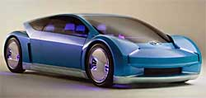  fuel cell car (Toyota)  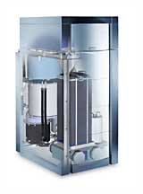  residential fuel cell system

Hydrogen as a fuel  All the means of transport we know today could be powered by hydrogen. There are two possibilities for doing so: Hydrogen is burnt in conventional engines instead of gasoline. The other option is the use of fuel cells which are generating electric power for an electric motor in the car.  The use of fuel cells in cars has some decisive advantages: There is only water emitted from the exhaust, it operates without noise and without vibrations and it is more efficient than a combustion engine - so it saves energy. When a fuel cell car is waiting at a traffic light there is no noise because the engine does not work. The noise from accelerating is much reduced as well. Our cities will become much quieter.  Motorcars with Fuel Cells  World-wide all the big motorcar producing companies are developing test cars with fuel cell drive systems. In Germany mainly DaimlerChrysler, Opel and Ford are the first to do so. BMW presented hydrogen powered cars very early but they are still concentrating on combustion engines. Though future vehicles of the 7-series will use a fuel cell for the electric power supply.  DaimlerChrysler wants to bring a serial A-class model with fuel cells up for sale beginning in 2005. Which fuel will be used then - hydrogen or methanol - has not been decided yet. At the moment the missing fuel station infrastructure is an obstacle to the broad market introduction of fuel cell cars.  Hydrogen Driven City buses  For buses the two different concepts of internal combustion engine and fuel cell exist as well. Compared with diesel buses they both have the advantage of greatly reduced pollutant emissions.  At the Munich Airport three hydrogen buses with internal combustion engines which were built by MAN and Neoplan are in operation since 1999. Meanwhile both companies are also testing fuel cell buses because they are convinced of the advantages of fuel cells, especially concerning operation in cities. It is planned to run a MAN city bus with a fuel cell in Berlin as well.  DaimlerChrysler wants to test some dozen of its "Nebus" city buses with fuel cells in regular service in the coming years.  Trucks, Trams, Railway Engines and Ships  There is hardly a means of transport for which no hydrogen or fuel cell concept exists. The use in trams or railway engines is in the discussion for all applications where there are not yet overhead lines or where these overhead lines would be really spoiling. In these cases there is a trade-off between the additional costs for hydrogen powered railway engines and the costs for overhead lines.  The use of hydrogen and fuel cells in trucks has not been tested yet, because on long-distance rides diesel engines work very efficiently. However the use of fuel cells in delivery vehicles operating in cities is very interesting because these vehicles are usually part of a fleet and have only a limited daily mileage. In the evenings they could be refilled in the depots. The "Hermes-Versand" in Hamburg, inter alia, runs seven Mercedes Sprinters (with internal combustion engines) to supply its customers. The next step will be the import of hydrogen from Iceland which will be renewably generated. As a result the hydrogen driven vehicles will have an excellent local and global emission balance.  Ships which are used in urban areas, like passenger ferries or pleasure boats, could considerably lower their emissions. In addition these ships are very quiet and really comfortable for the passengers because the fuel cell works without noise. In big ships the electric power supply is to be met by fuel cells first, allowing the generators to be stopped when in harbour.  Hydrogen Driven Aircrafts  Since the beginning of the 80`s the Russian manufacturer Tupolev worked on aircraft versions with cryogen energy supply. In 1988 Tupolev presented a TU 154 of which the right of the three engines was modified so that it could be powered by liquid hydrogen and also tanks for hydrogen were installed.  The engine was working successfully for the whole flight phase which lasted more than 100 hours.  Since the beginning of the 90`s Daimler-Chrysler Aerospace and Tupolev co-operate in the field of cryogen aircraft technology. This co-operation is called Cryoplane Program. The aim is to switch the engines of a turboprop-aircraft (DO 328) over to hydrogen propulsion and to install a hydrogen supply system on board. The experience to be gained in this project can be transferred to big passenger aircrafts (Airbus) later on. |   BMW with internal combustion engine for hydrogen  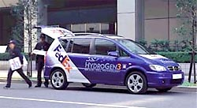  fuel cell delivery car (GM/Opel)  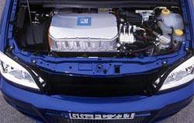  the fuel cell "motor"  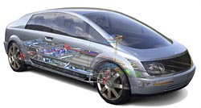  the Hywire concept car (GM/Opel)    fuel cell bus by MAN    airport bus with internal hydrogen combustion engine  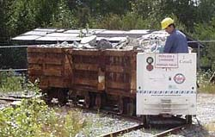  fuel cell locomotive for mining    fuel cell delivery truck (DC)    sightseeing boat with fuel cell propulsion    hydrogen aircraft    concept aircraft "cryoplane"

Hydrogen at home  The most important stationary application of fuel cells and hydrogen is the co-generation of electric power and heat in a fuel cell heating and power station. The advantage of making use of both products - electric power and heat - is the very high overall system efficiency thus making the best possible use of the primary energy sources.  Such cogeneration fuel cell power stations can be realised even in very small construction sizes. Most common will be systems having the size of regular residential heating systems or of gas heating boilers. When these systems were produced in large numbers they would be only slightly more expensive than conventional heating boilers but in addition they are "incidentally" generating electric power!  One can imagine how our energy system would change if millions of such plants were installed directly in residential buildings. The generation of electric power would become decentralised and we would use the primary energy sources more efficiently.  In Europe only a very small part of all power stations uses the "waste heat" of the power generation for heating purposes. Conversely heating installations burn oil and gas without generating electric power.  Even if in the beginning the fuel cell is to be operated together with a reformer which converts natural gas (i.e. a fossil fuel) the overall energy consumption and therefore the greenhouse gas emissions would decrease considerably. | 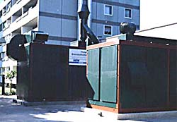  fuel cell system for an apartment house  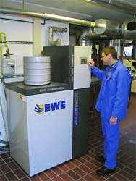  1 kW home fuel cell system (SOFC)  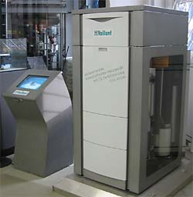  home fuel cell system (PEM)

Hydrogen in your hands  A great variety of possible applications for fuel cells and hydrogen can be found in the energy supply of portable devices: mobile phones, laptops, walkmen, camcorders and many other things could be powered by hydrogen and by fuel cells in the size of batteries.  In this exposition you can have a look at a computer powered by a fuel cell. Its operation time far exceeds the operation time of computers powered by conventional accumulators. And when the hydrogen draws to an end one simply inserts a new cartridge. The empty cartridges can be refilled.  Fuel cells which are even smaller, so called micro fuel cells, could be integrated in mobile phones. Prototypes with an operation time of fifty hours have already been presented.  Portable applications with higher power ratings are in the development stage as well. In the USA the lighting appliances on some construction sites in remote regions are already powered by fuel cells. Provided there is a big enough tank these systems work for weeks and they are cheaper to run than batteries with equivalent capacities. |   mobile phone (motorola)    notebook power supply (SMFC)    portable power supply (Ballard)

Hydrogen Demonstration Projects  There are already a lot of hydrogen demonstration projects throughout Europe. |   CUTE -European fuel cell bus project

Is hydrogen dangerous?  Hydrogen is highly inflammable, that means it easily reacts with oxygen and when it burns water is produced. Exactly this characteristic makes it suitable as a fuel.  Hydrogen has no greater danger potential than oil, natural gas or uranium. With regard to its physical and chemical specifications hydrogen is not particularly dangerous. Therefore, e.g. in Germany, the safety precautions and regulations for hydrogen do not differ from those for every other burnable gas.  In car accidents or air crashes liquid fuels often lead to fire slicks and in consequence frequently result in fatal injuries. In contrast to this hydrogen escapes upwards into the air very fast as proved by the accident of the airship "Hindenburg" in 1937. On the other hand one has to consider that there is an increased explosion hazard when hydrogen is set free in closed rooms, e.g. in garages or tunnels. In closed rooms good ventilation and perhaps additional safety precautions must be provided.  The chemical industry has been using hydrogen for hundred years. The experiences concerning safety are positive. |   The outbreak of the fire which destroyed the airship LZ 129 "Hindenburg" in Lakehurst in 1937 had nothing to do with the hydrogen gas which had been stored on board in large amounts as ascending force. The reasons for the accident were the chemical and electric characteristics of the paint applied to the outer skin in combination with the particular weather situation in Lakehurst on the day of the tragedy. In a thunderstorm a electrostatic stroke set the highly inflammable paint on fire. Then the fire spread to the hydrogen.  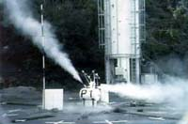  If the airship really had "exploded", like it is so often said, then this photo could not have been taken. The truth is that the hydrogen burnt while escaping upwards. Any passenger who did not jump off survived the accident! If a liquid fuel had started burning the accident would have been much more disastrous, because a liquid fuel always collects at the bottom and builds a fire slick!  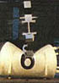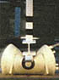

Hydrogen and fuel cells - a perfect combination  In this chapter we learn the basic facts of fuel cells. What for we need fuel cells, how they work and what is already reality.  Fuel cells gives us a very efficient way to produce electric power and heat. In the whole circle of renewable energies they are the final element. The sun provides energy, solar cells or wind power catch it for us, hydrogen is the storage and the medium to transport the energy and the fuel cells generate the energy whenever and whereever it is needed.  If we get into our car, if we need heat and electricity at home or if we just listen music on our walkmen. The energy could be provided by a fuel cell. | 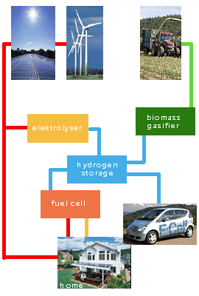

An invention with history  Back in the year 1839 the foundation stone for today's fuel cell technology has already been laid. It was the Welsh justice and physician Sir William Robert Grove (1811-1896) who developed the first working prototype. This prototype consisted of two platinum electrodes which were separately surrounded by a glass cylinder. One of the cylinders was filled with hydrogen the other with oxygen. Both electrodes were immersed in diluted sulphuric acid -which was the electrolyte- and created the electric connection. At the electrodes voltage was produced. This voltage was very low and therefore Grove linked several of these fuel cells to get a higher voltage.  Groves`s contemporaries underestimated the importance of his discovery and the fuel cell was forgotten. Only in the 1950`s, against the background of the Cold War, his idea was taken up again. Space travel and military technology required compact and powerful energy sources.  Spacecraft and submarines require electric power and it is not possible to work with internal combustion engines. Because of batteries being too heavy for spacecrafts, NASA (e.g. in the Apollo program) decided in favour of the direct chemical generation of electric power by fuel cells.  The civil use of fuel cells became interesting only during the last years.  At the beginning of the 90`s scientists and engineers developed different new concepts and technologies which made it possible to increase efficiency continually and to decrease costs at the same time. Today fuel cells can be used for a lot of different applications: for vehicle engines, for residential heating systems and also for big power stations with a power rating of several megawatts as well as for smallest applications like in mobile phones or mobile computers.  The fuel cell really has the potential to revolutionise the world of energy technology! | 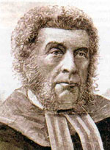  Sir Wiliam Robert Grove  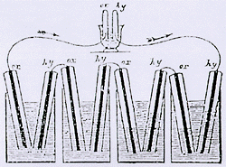  Groves experiment

Basic construction  Fuel cells have a very simple structure. The cell itself consists of three layers, one above the other:  The first layer is the anode, the second an electrolyte and the third layer is the cathode.  Anode and cathode serve as catalyst. The layer in the middle consists of a carrier structure which absorbs the electrolyte. In different types of fuel cells different substances are used as electrolyte. Some electrolytes are liquid and some are solid with a membrane structure.  Because one cell generates only low voltage several cells get stacked according to the requested voltage. This arrangement is called "stack". |   princip of a cell    Many cells combined are called a fuel cell stack. The bipolar plates (dark blue) seperate the cells and avoid electric connections.

What exactly does a fuel cell?  The fuel cell reverses the process of electrolysis which is known from school. In the process of electrolysis by applying electric power water is decomposed into the gaseous components oxygen and hydrogen.  The fuel cell takes exactly these two substances and converts them to water again. In theory the same amount of energy which has been used for the electrolysis is set free by this conversion. In practice insignificant losses are caused by different physical-chemical processes.  So to say electric power is stored in hydrogen. Therefore we have a gas at our disposal in which electric power can be stored and this gas is hydrogen. In fuel cells we get back the electric power stored in the hydrogen. Most fuel cells are operating with air, so there is no need to store oxygen.  There are different types of fuel cells which are distinguished by construction and mode of function. In the next chapters we will describe the fundamental modes of operation of different fuel cells...: | 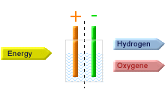  electrolysis  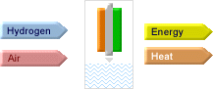  a fuel cell

The first "modern" fuel cell  Apart from Grove`s prototype the alkaline fuel cell - AFC- was the first type of fuel cell.  It was in use, and still is in use today, for space travel and submarine engines.  It is the only type of fuel cell that requires oxygen and hydrogen in purest form because even smallest amounts of dirt would destroy the cell. The electrolyte consists of caustic potash.  Today there are AFC available that can be operated with air. A very good filter is needed to clean the air to avoid contamination of the fuel cell. |   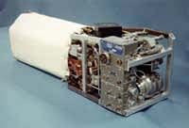  AFC used in the space shuttle

The function of the AFC in seven steps:
Step 1
Inside the two seperate gas supply cicuits the gaseous oxygene and hydrogen flow into the gas area and the catalyzer.
Step 2
While getting in contact with the catalyzer the hydrogen molecules (H2) are splitted into two H+ protons. At the same time each hydrogen atom sends out one electron.
Step 3
Dhe electrons move from the anode to the cathode and cause an electric current. This electric current supplies an electric capacitor with electric power.

Step 4
Respectively four electrons recombine with one hydrogen molecule at the cathode.
Step 5
The now generated oxygene ions react with water to OH ions.
Step 6
This hydroxide ions move through the electrolyte (potash solution) to the anode.
Step 7
The hydroxide ions react at the anode with the protons to water. The water is partly leaded back to the cathode to enhance the further reaction.

AFC applications  Alkaline fuel cells have been in use in manned space travel which would not have been possible without the fuel cell. In the Apollo and in the Apollo-Soyuz program as well as in the Skylab and in space shuttles alkaline fuel cells were and are in use.  At the moment AFCs are in the development stage for the use as vehicle drives. But the fact that AFCs can not be fed directly with air (but only with pure oxygen) is a big disadvantage.  CO2 has to be removed from the air in the beginning to avoid a "poisoning" of the electrolyte. This requires additional devices in the fuel cell system.  Alkaline fuel cells are especially suitable for niche vehicles because they can be produced quite cheaply even in small numbers. An example for such an application are the famous London taxis. | 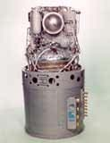  fuel cell from the Apollo program    a taxi driven by a AFC  the first fuel cell boat with an AFC

The proton exchange membrane fuel cell - PEMFC  is easy to handle. It is very light, it is very efficient and as reaction gas it requires only atmospheric oxygen instead of pure oxygen. The hydrogen has to have the typical purity.  PEM fuel cells are very sensitive to carbon monoxide (CO). This gas might block the anode catalyst and subsequently lead to a reduced performance.  The electrolyte consists of a solid proton exchange membrane (PEM) made from sulphonated polymer.  The power output of a PEM fuel cell can be controled very dynamically. Therefore it is perfectly suitable for mobile applications and decentralised power plants.  Among the development of fuel cells the PEMFC is most paramount at the moment. One reason is the cell`s enormous potential to be mass produced. The target costs for a fuel cell stack are about 200 DM/kW. | 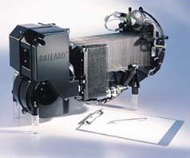  1.2 kW PEM fuel cell system (Ballard)  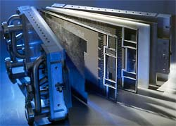  PEM fuel cell stack components

The function of the PEM fuel cell in seven steps:
Step 1
Inside the two seperate gas supply cicuits the gaseous oxygene and hydrogen flow into the gas area and the catalyzer.
Step 2
While getting in contact with the catalyzer the hydrogen molecules (H2) are splitted into two H+ protons. At the same time each hydrogen atom sends out one electron.
Step 3
The protons move through the electrolyte (membrane) to the cathode area.

Step 4
Dhe electrons move from the anode to the cathode and cause an electric current. This electric current supplies an electric capacitor with electric power.
Step 5
Respectively four electrons recombine with one hydrogen molecule at the cathode.
Step 6
The now generated oxygene ions have a negative load. They move to the positiv loaded protons.
Step 7
The oxygene ions give their electrons to the two protons and oxidize to water.

Applications for PEM fuel cells  The PEM fuel cell can be used for a great variety of applications such as mobile phones, cogeneration of power and heat or drive trains for automobiles.  PEM fuel cell drive systems are now demonstrated in many prototype vehicles. Motorcars, minibuses and city buses will be the first types of vehicles to be fitted and sold with fuel cells.  Later on vans and some other light commercial vehicles will be added. Only heavy trucks are not probable to be offered with PEM fuel cells in the near future because very large hydrogen tanks would be needed to drive long distances and in addition the diesel engines work very efficiently in big trucks.  PEM fuel cells are also suitable for rail vehicles like trams or regional railways. In this case overhead lines are not required.  PEM fuel cells are perfectly suitable for the co-generation of electric power and heat. Small applications e.g. in houses as well as applications for large buildings like hospitals are in the development stage.  It must be reckoned that the commercialisation will take place in the next two years. In these applications the hydrogen is generated from natural gas or liquid gas in reformers.  Portable devices which require electric power are also possible applications of PEM fuel cells. Most prominent is the field of camping equipment. But also accumulator-drills or lawn-mowers could be driven by PEM fuel cells. The first fuel cell systems for mobile phones and laptops have already been developed. | 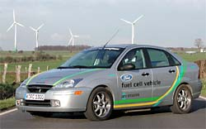  fuel cell car (Ford)  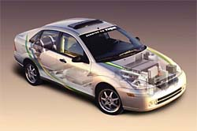  PEM fuel cell integration (Ford)  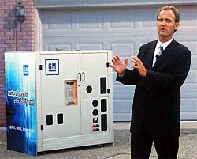  stationary fuel cell by GM  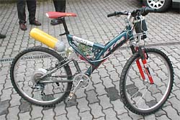  bycicle with PEM fuel cell (front) and hydrogen storage

The phosphoric acid fuel cell - PAFC  is the type of fuel cell which has reached the highest stage of technological and commercial development.  Because it is run at a high operating temperature it is suited perfectly for cogeneration. Highly concentrated phosphoric acid which is bond in a gel matrix serves as catalyst.  The PAFC requires atmospheric oxygen and hydrogen as reduction gases. One disadvantage is that the phosphoric acid effloresces irreversibly when temperature sinks below 42°. When this happens the fuel cell becomes unusable. | 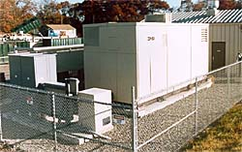  200 kW PAFC cogeneration unit (Onsi)

The function of the PAFC in seven steps
Step 1
nside the two seperate gas supply cicuits the gaseous oxygene and hydrogen flow into the gas area and the catalyzer.
Step 2
While getting in contact with the catalyzer the hydrogen molecules (H2) are splitted into two H+ protons. At the same time each hydrogen atom sends out an electron.
Step 3
The protons move through the electrolyte (highly concentrated phosphoric acid) to the cathode area.
Step 4
The electrons move into the anode and cause an electric current. This electric current supplies an electric capacitor with electric power.
Step 5
Respectively four electrons recombine with one hydrogen molecule at the cathode.
Step 6
The now generated oxygene ions have a negative load. They now move to the positiv loaded protons.
Step 7
The oxygene ions give their electrons to the two protons and oxidize with them to water.
Applications for the PAFC  The PAFC is used exclusively for the cogeneration of power and heat.  The PAFC was the first commercially available fuel cell. In units with an electric power of 200 kW and a thermal power of 220 kW it is offered by the American company ONSI. Up to now more then 200 PAFC plants have been installed world-wide. | 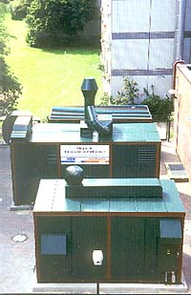  fuel cell power plant for an apartment house  (supply of heat and electric power)

The molten carbonate fuel cell - MCFC  operates at high temperature ranges of 580 to 660°C.  The advantage of this type of cell is that there is no need for gas purification. In addition the cell is insensitive to carbon monoxide poisoning.  Natural gas, coal gas, biogas and synthesis gas can be used directly as fuels. No reformer is needed.  The electrolyte in this fuel cell is a salt melting of combined alkali carbonates (Li2CO3 / K2CO3). | 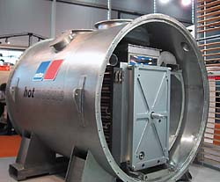  280 kW MC fuel cell (Hot Module by mtu)

MCFC Applications  Molten carbonate fuel cells are being developed for stationary applications. They are especially useful for the cogeneration of power and heat in industrial and commercial applications where high temperatures are required (process heat) because the MCFC operates at temperatures around 650°C.  Plants with around 300 kW power rating are in the development but plants with more power are also possible. Apart from these stationary applications ship engines on the basis of MCFCs are being developed as well. | 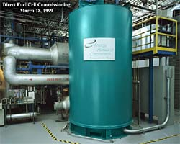  2 MW MCFC power station
Glossary
AFC | alkaline fuel cell; with alkaline electrolyte, operating temperature 60 to 90°C; fuel: pure hydrogen; can only be operated with pure oxygen or with air if the CO₂ has been removed; state of the art: so far used mainly in military applications and space travel; presently developed and manufactured by ZeTek Power for terrestrial applications.
biomass | all organic substances: plants, wood chips, bales of straw, liquid manure, organic wastes etc.
biomass converter | (technical) system that converts organic feedstock (biomass) into a technically usable energy carrier: e.g. steam reformer.
boil-off loss | amount of gas that vaporizes in a liquid gas storage through external heating (ambient temperature). The gas will only be vented when the operating pressure is exceeded.
catalyst | a catalyst is a material that facilitates, accelerates etc. a chemical reaction retaining its own properties and without being consumed.
catalytic combustion | in a catalytic combustion the combustion temperature is reduced by a catalyst. Lower temperatures result in near zero nitrous oxide (NO_{x}) emissions.
CGH₂ or CH₂ | compressed gaseous hydrogen
compressed gas storage | storage device for gases (e.g. hydrogen, natural gas, nitrogen) at room temperature under high pressure (typically some 20 MPa).
compressor | device for increasing gas pressure or gas flow rate.
cryoadsorption storage | special type of graphite storage. Carbon is able to adsorb hydrogen. Different qualities of carbon can adsorb higher quantities of hydrogen under certain temperature and pressure conditions than could be stored without the carbon under the same conditions. Temperatures are below 0°C (cryogenic) and above boiling temperature of hydrogen (20 K). The pressure levels are above 5 MPa.
cryogenic | Greek krýos: cold, frost. Applied to gases cryogenic refers to low temperatures where the gases are in their liquid phase. For natural gas the boiling temperature (where the phase transition from liquid to gaseous occurs) is -161.5°C (111.5 K) and for hydrogen it is -253°C (20 K).
dissociation of water at high temperatures | above 2000 K (1700°C approximately), a temperature that can be achieved in solar furnaces without major problems, water is split into hydrogen and oxygen. Ceramic membranes permitting the permeation of hydrogen but inhibiting that of oxygen are used for the gas separation. This process is in a very early stage of development.
DMFC | direct methanol fuel cell; fuel: methanol; state of the art: basic research.
electro farming | concept that comprises the conversion of energy crops (biomass) via steam reforming and fuel cells into electricity. This way, in principle, electricity is „farmed".
elektrolyzer | In an electrolyzer, an electric current splits water into hydrogen and oxygen. Reverse process of the fuel cell.
energy carrier | medium (gaseous, e.g. natural gas, hydrogen; liquid, e.g. petrol, biofuels; solid, e.g. wood, coal) in which energy is stored in chemical form; by means of energy carriers energy is storable and transportable. Non-material energy carriers are e.g. electricity and solar radiation. Within certain limits and with certain losses energy carriers can be converted into one another (e.g. solar radiation into electricity, electricity into hydrogen, hydrogen into electricity, electricity into light etc.).
energy crop | plants that are grown for the sole purpose of energy production, not for food production (e.g. rape used for the production of biofuels). The growing of energy crops is not yet very wide-spread.
fuel cell | A fuel cell is an electrochemical device in which hydrogen and oxygen combine in an controlled manner (in contrast to combustion or explosion) to directly produce an electric current and heat. Reverse process of electrolyzer.
full composite storage | storage tank produced entirely from composite materials. Presently, the market introduction of full composite compressed gas storages takes place.
GH₂ | gaseous hydrogen. At room temperature (above -253°C or 20 K, to be exact) hydrogen is gaseous independent of the pressure.
graphite storage | carbon is able to adsorb hydrogen. The amount of adsorbed hydrogen depends on temperature, pressure and the quality/ structure of the carbon used. Carbon structures in the nanometers range (one nanometer corresponds to 10⁻⁹ meters), e.g. balls, tubes or fibers, seem to be very promising. The developments are in a very early stage.
H₂ | hydrogen
H₂/O₂ steam generator | device that produces steam via the reaction of hydrogen and oxygen. The subsequent injection of water allows a temperature control between 200 and 2000°C. H₂/O₂ steam generators have been developed as a spinning reserve of large power plants, but have not yet been applied.
heating value | energy content of an energy carrier. Upper and lower heating value are distinguished. Upper heating value: total energy content of the energy carrier. Lower heating value: energy content reduced by the condensation energy (latent heat) of the product gas (the steam in the product gas, to be exact).
hydrogen | H is the chemical symbol for hydrogen, the lightest element of the table of elements and the most abundant element of the universe. In general, hydrogen will be found in molecular form, i.e. as a hydrogen molecule composed of two hydrogen atoms (H₂), or in other compounds (e.g. in water – H₂O, organic substances). Hydrogen as secondary energy carrier is seen as the key component of a global renewable world energy supply.
hydrogen as solar energy carrier | solar hydrogen energy economy
hydrogen energy economy | energy economy where hydrogen is used as the secondary energy carrier.
hydrogen liquefaction | liquefaction of hydrogen, which is gaseous at room temperature, by cooling it below -253°C (20 K).
hydrogen motor | combustion engine which uses hydrogen as a fuel.
hydrogen propulsion | mobile propulsion system that uses hydrogen as fuel. The propulsion energy is produced in a fuel cell and an electric motor, in a combustion engine (hydrogen motor) or a gas turbine.
hydrogen storage | compressed gas storage, cryoadsorption storage, graphite storage, iron sponge storage, liquid hydrogen storage, metal hydride storage.
hydrogen jet engine | hydrogen fueled jet engine for aviation use
iron sponge storage | iron sponge can be used as a hydrogen storage material. Hydrogen and „rust" (Fe₃O₄) are converted into pure iron („iron sponge") which is transported to the hydrogen consumption site. In the reverse reaction (oxidation) „rust" is produced liberating the hydrogen. The iron sponge storage can also be filled/ loaded with synthesis gas (mixture of hydrogen and carbon monoxide) also liberating pure hydrogen in the reverse reaction. Iron sponge storage is in an early stage of development.
LH₂ | liquid hydrogen
LH₂ storage | liquid hydrogen storage
liquid gas storage | tanks for the storage of liquids that are gaseous under normal conditions (room temperature, atmospheric pressure). The substances are kept in the liquid phase either by applying a slight over-pressure (e.g. LPG – liquefied petroleum gas; 0.5 - 1.5 MPa) or by storing it at low temperatures in superinsulated devices (e.g. hydrogen at -253°C).
liquid hydrogen | below -253°C or 20 K hydrogen is in its liquid phase.
liquid hydrogen storage | liquid gas storage for cryogenic hydrogen at atmospheric pressure and cryogenic temperatures.
MCFC | molten carbonate fuel cell; with molten alkaline carbonate electrolyte; operating temperature 600 to 650°C; fuel: carbon containing gases (e.g. natural gas, synthesis gas); state of the art: prototypes are being manufactured, demonstration planned for the period 1997 to 2000, first small series production starting after 2000.
metal hydride storage | device that can store hydrogen by use of a metal alloy. The hydrogen is soaked into the alloy like into a sponge and fills the spaces in the crystal lattice of the alloy. The storage is filled applying a modest over-pressure and is usually operated in the temperature range of 20 - 80°C.
MPa | mega Pascals (SI pressure unit); one MPa corresponds to a pressure of 10 atmospheres (10 bar_{abs}).
PAFC | phosphoric acid fuel cell; with phosphorous electrolyte; operating temperature 160 up to 220°C; fuel: pure hydrogen; state of the art: 200 kW_{e} systems commercially available.
partial oxidation | conversion of hydrocarbons (diesel, residual oil etc.) into a synthesis gas that consists of hydrogen, carbon monoxide (CO) and carbon dioxide (CO₂). The necessary energy is supplied by the combustion („oxidation") of parts („partial") of the feedstock in the process itself. Partial oxidation is a common process for the production of hydrogen (the synthesis gas is converted into pure hydrogen by converting the carbon monoxide and water into carbon dioxide and hydrogen and by subsequently separating the carbon dioxide).
PEFC | PEMFC
PEMFC | proton exchange membrane fuel cell; with proton conducting membrane as electrolyte; operating temperature 60 to 80°C; fuel: pure hydrogen; state of the art: in 1997 first systems in commercial operation in the very small power range (>50 W), larger units in series production for mobile and stationary applications before the turn of the century.
photobiological water splitting | there are different biological processes that liberate hydrogen or where hydrogen is produced as an intermediate product. Photobiological processes as e.g. photosynthesis use the solar radiation as source of energy, while fermentation processes that take place in the absence of light take advantage of the energy stored in the feedstock (e.g. glucose). There are several first efforts to use photobiological water splitting for the technical production of hydrogen.
primary energy | energy carrier to be found in nature (e.g. solar energy, wood, coal, petroleum, natural gas).
primary energy carrier | primary energy, energy carrier
renewable energy | form of energy which is never exhausted because it is renewed by nature (within short time scales; e.g. wind, solar radiation, hydro power).
renewable raw material | biomass that is only harvested to an extent that allows a (natural) regeneration. It is used for energetic or other purposes (e.g. as a construction material).
secondary energy | energy carrier which has been produced from primary energy in a conversion process (e.g. electricity, hydrogen, petrol).
secondary energy carrier | secondary energy, energy carrier
SOFC | solid oxide fuel cell; with oxygen ion conducting ceramic electrolyte; operating temperature 800 to 1000°C; fuel: pure hydrogen, carbon containing gases (e.g. natural gas, synthesis gas); state of the art: first demonstration projects are presently being carried out, commercialization planned after 1998.
solar energy | solar radiation reaching the earth and its use for the production of electricity and heat.
solar hydrogen energy economy | energy economy where solar energy is the primary energy and hydrogen is used as secondary energy carrier.
SPFC | solid polymer fuel cell = PEMFC
steam reformer | device for steam reforming
steam reforming | catalytic conversion of light hydrocarbons (biomass, fossil energy carriers e.g. natural gas) producing a synthesis gas that consists of hydrogen (H₂), carbon monoxide (CO) and methane (CH₄). The process is heat consuming. Steam reforming of natural gas is a common process for the production of hydrogen (the synthesis gas is converted into pure hydrogen by converting the carbon monoxide and water into carbon dioxide and hydrogen and by subsequently separating the carbon dioxide).

Sursa de informare: Internet.

Olaru Andrei.

